Final Report

### **Title:** Trail Tracker

### **Description:**

On this website, the user will be able to look through a list of different trails located in California. They will be given the option to login or create an account. Once logged in, you can add trails to your trail list and view them under the ‘My Trails’ page. If the user is an admin they will be able to access the ‘Admin’ where they will be able to see all the trails along with an ‘update’ button. They will also have an option to create a new trail that is added to the database.

Admin Username: Admin

Admin Password: admin

Fetch calls to APIs are in the displayTrails and setBackground functions in script.js

### **Task distribution:**

| Student | Tasks |
| --- | --- |
| CJ Turetzky | Local api development, node development |
| Andrea Ultreras | Browse feature, updata/add/admin pages, website styling |
| Tuan Nguyen | Database development |
| Orion Furnish | Login and account creation, node development |

### 

### **Changes from original design:**

We stuck closely to the original plans. The main difference from the plans is that we didn’t include the delete option when listing the trails for the admin and we didn’t include pictures of the individual trails.

Original plans:

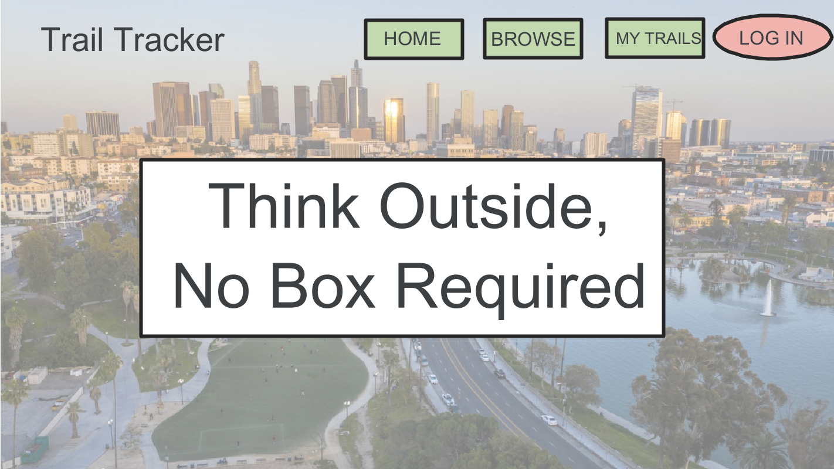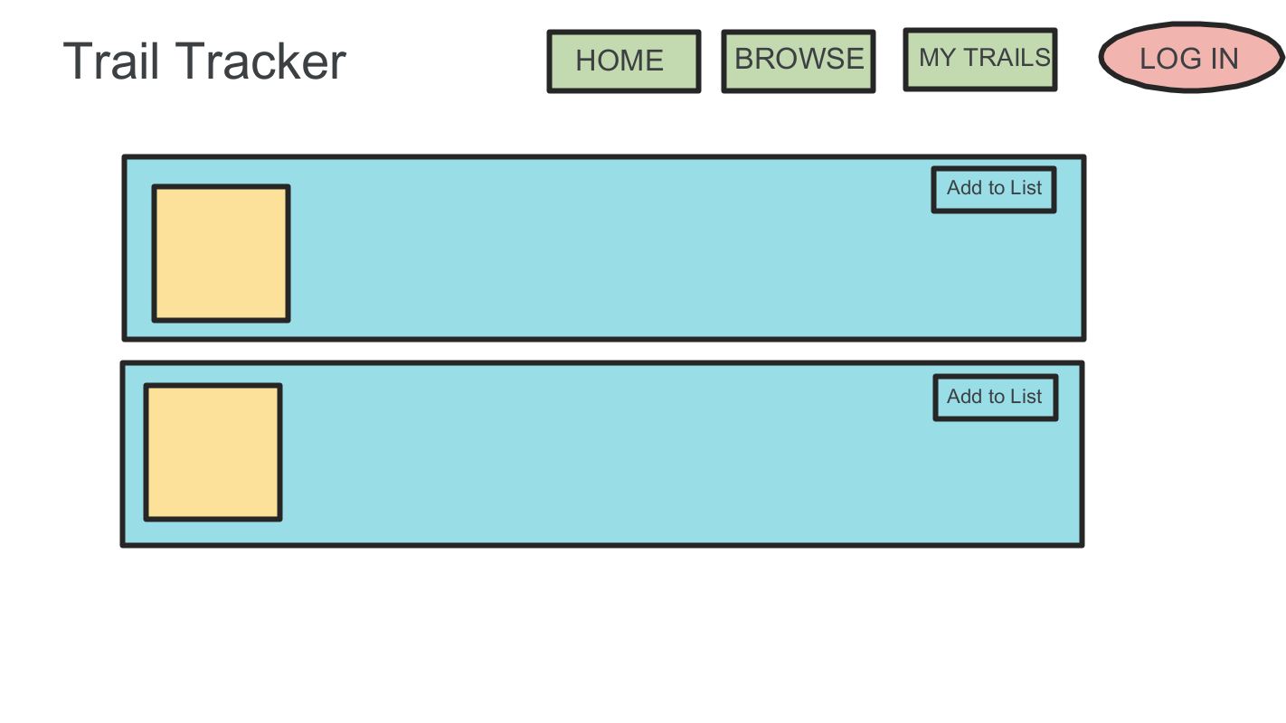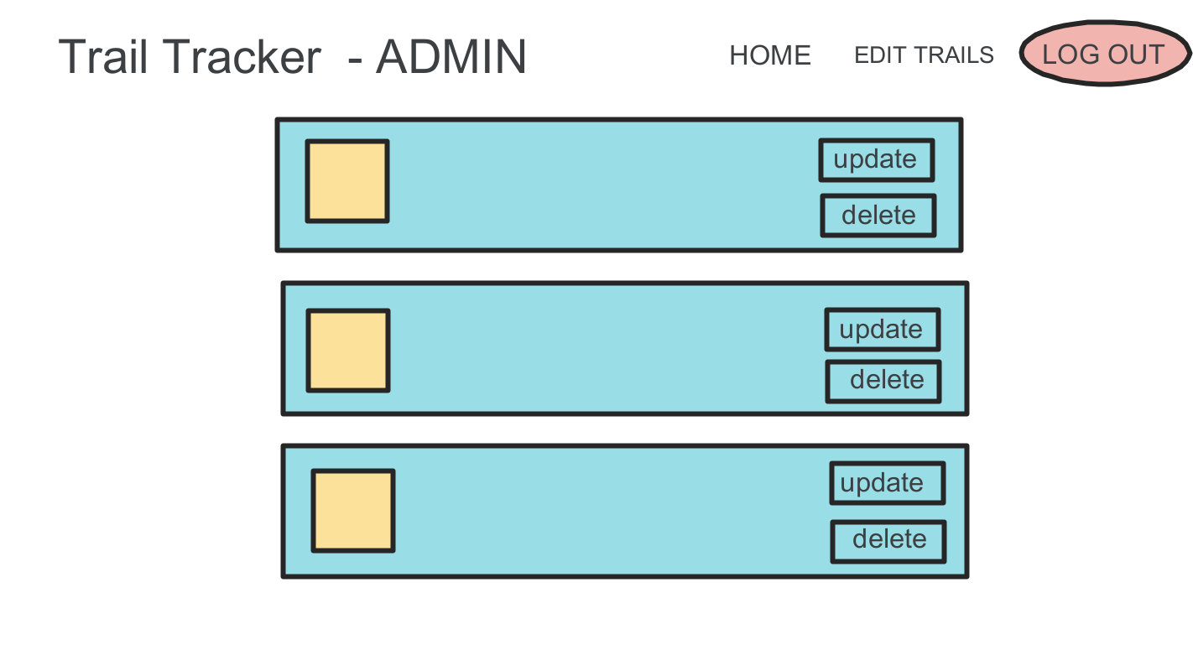

### 

### **Database Schema and Screenshots of the finished project:**

| Saved Trials |  |
| --- | --- |
| Users |  |
| Trails |  |

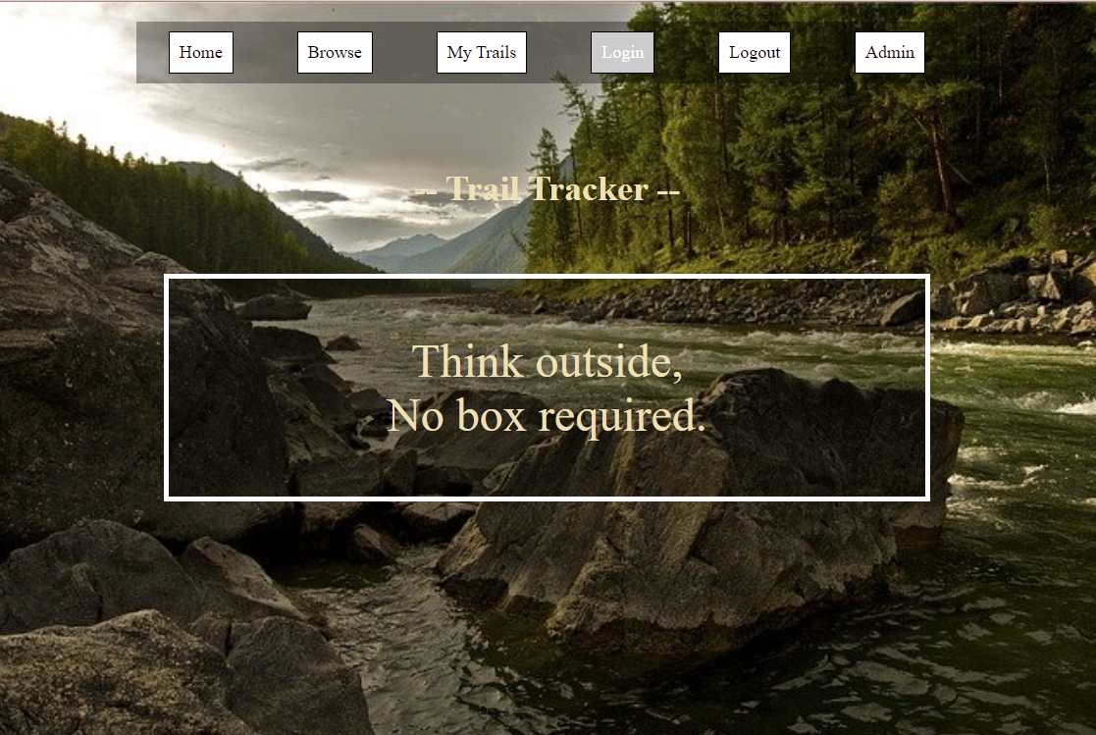



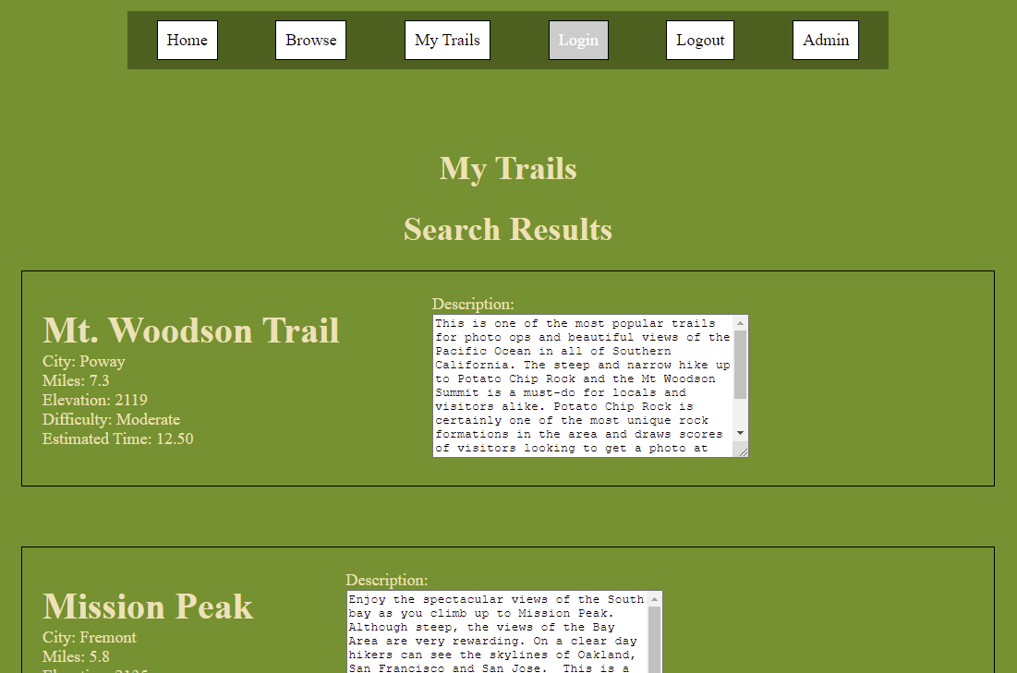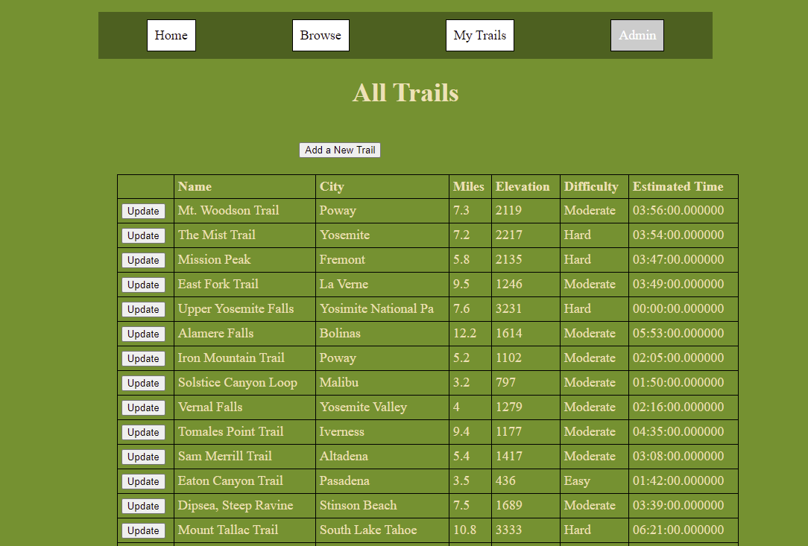

DROP TABLE IF EXISTS `saved_trails`;

CREATE TABLE `saved_trails` (

`User_ID` int NOT NULL,

`Trail_ID` int NOT NULL

) ENGINE=InnoDB DEFAULT CHARSET=utf8mb4 COLLATE=utf8mb4_0900_ai_ci;

DROP TABLE IF EXISTS `trails`;

CREATE TABLE `trails` (

`Trail_ID` int NOT NULL,

`Name` varchar(20) NOT NULL,

`City` varchar(20) NOT NULL,

`Miles` float NOT NULL,

`Elevation` int NOT NULL,

`Difficulty` varchar(20) NOT NULL,

`Estimated_Time` time(6) NOT NULL,

`Description` varchar(500) NOT NULL

) ENGINE=InnoDB DEFAULT CHARSET=utf8mb4 COLLATE=utf8mb4_0900_ai_ci;

INSERT INTO `trails` (`Trail_ID`, `Name`, `City`, `Miles`, `Elevation`, `Difficulty`, `Estimated_Time`, `Description`) VALUES

(1, 'Mt. Woodson Trail', 'Poway', 7.3, 2119, 'Moderate', '03:56:00.000000', 'This is one of the most popular trails for photo ops and beautiful views of the Pacific Ocean in all of Southern California. The steep and narrow hike up to Potato Chip Rock and the Mt Woodson Summit is a must-do for locals and visitors alike. Potato Chip Rock is certainly one of the most unique rock formations in the area and draws scores of visitors looking to get a photo at the top. Located in northern San Diego County, the Mount Woodson Trailhead starts at the end of Lake Poway Road and off'),

(2, 'The Mist Trail', 'Yosemite', 7.2, 2217, 'Hard', '03:54:00.000000', 'Yosemite National Park charges a fee to enter. Fees are per vehicle or per motorcycle. If you are entering on foot, horse, or bike the fee is per person. You can also purchase a park-specific annual pass. Yosemite is open with some services limited due to COVID-19. Reservations are required to drive into Yosemite. Some services and facilities are limited, and shuttles are not operating. See the park website for more info: https://www.nps.gov/yose/planyourvisit/covid19.htm SEASONAL CLOSURE: Duri'),

(3, 'Mission Peak', 'Fremont', 5.8, 2135, 'Hard', '03:47:00.000000', 'Enjoy the spectacular views of the South bay as you climb up to Mission Peak. Although steep, the views of the Bay Area are very rewarding. On a clear day hikers can see the skylines of Oakland, San Francisco and San Jose. This is a moderate to strenuous trail with a constant uphill climb until you reach the summit. The trail is a well maintained gravel base until the last half mile. From this point the trail is hard pack dirt and rocky. Difficulty would definitely increase during the rainy sea'),

(4, 'East Fork Trail', 'La Verne', 9.5, 1246, 'Moderate', '03:49:00.000000', 'FIRE CLOSURE: As of February 2021 there are closures in this park or area due to wildfire. For more information, please visit https://www.fs.usda.gov/alerts/angeles/alerts-notices. This trail requires an Adventure Pass. This pass can be bought at many small shops in the area. Several hikers have reported getting ticketed when parking along the road leading up the the trailhead. Please note that although the area/bridge are private property, it is open to hikers. This trip takes you along th'),

(5, 'Upper Yosemite Falls', 'Yosimite National Pa', 7.6, 3231, 'Hard', '00:00:00.000000', 'Yosemite National Park charges a fee to enter. Fees are per vehicle or per motorcycle. If you are entering on foot, horse, or bike the fee is per person. You can also purchase a park-specific annual pass. Yosemite is open with some services limited due to COVID-19. Reservations are required to drive into Yosemite. Some services and facilities are limited, and shuttles are not operating. See the park website for more info: https://www.nps.gov/yose/planyourvisit/covid19.htm Enjoy the thrilling vi'),

(6, 'Alamere Falls', 'Bolinas', 12.2, 1614, 'Moderate', '05:53:00.000000', 'Alamere Falls is a tidefall waterfall that flows into the ocean in Point Reyes National Seashore, northwest of San Francisco in Marin County. This popular Bay Area coastal hike can be reached via the Coast Trail from the Palomarin Trailhead. The parking area can be accessed at the end of Mesa Road outside of Bolinas. The trail offers great views of the Pacific Ocean - including the Farallon Islands on a clear day - as well as Bass and Pelican lakes. This is a well-marked coastal trail to Alamer'),

(7, 'Iron Mountain Trail', 'Poway', 5.2, 1102, 'Moderate', '02:05:00.000000', 'One of San Diego\'s most popular hikes, the Iron Mountain Trail leads to the second highest peak in Poway and offers great views of Northern San Diego County. On a clear day, hikers can see Mt. Woodson as well as the Catalina Islands. The hike takes place just west of the Boulder Oaks Preserve and the Iron Mountain trailhead is accessed just south of the intersection of Poway Road and CA - 67. There is no shade on this hike so bring plenty of water and sunscreen. The trail starts flat along a w'),

(8, 'Solstice Canyon Loop', 'Malibu', 3.2, 797, 'Moderate', '01:50:00.000000', 'This is an incredibly picturesque, mostly shaded canyon hike in the Santa Monica Mountains. The Solstice Canyon Trail is a popular, well-maintained route with some spur-trail opportunities for more adventurous travelers. Some of the highlights include the oldest still-standing stone building in Malibu, a small waterfall and creek, and several ruins - including the ruins of a moderate mansion. From the gate, follow the service road that runs along the right side of the creek. Bear right at the '),

(9, 'Vernal Falls', 'Yosemite Valley', 4, 1279, 'Moderate', '02:16:00.000000', 'Yosemite National Park charges a fee to enter. Fees are per vehicle or per motorcycle. If you are entering on foot, horse, or bike the fee is per person. You can also purchase a park-specific annual pass. Yosemite is open with some services limited due to COVID-19. Reservations are required to drive into Yosemite. Some services and facilities are limited, and shuttles are not operating. See the park website for more info: https://www.nps.gov/yose/planyourvisit/covid19.htm The Mist Trail from it'),

(10, 'Tomales Point Trail', 'Iverness', 9.4, 1177, 'Moderate', '04:35:00.000000', 'FIRE CLOSURE: As of March 2021, there are closures in this park or area due to wildfire. For more information, please visit https://www.nps.gov/pore/planyourvisit/hiking_trail_advisories.htm This Tomales Point Trail offers spectacular views of Tomales Bay, Bodega Bay, and the Pacific Ocean. Travelling to the end of the Point Reyes Peninsula, this hike is a bay area favorite! The peninsula is home to a tule elk reserve making it a prime for wildlife viewing. The first 3 miles to Historic Pierc'),

(11, 'Sam Merrill Trail', 'Altadena', 5.4, 1417, 'Moderate', '03:08:00.000000', 'FIRE CLOSURE: As of February 2021 there are closures in this park or area due to wildfire. For more information, please visit https://www.fs.usda.gov/alerts/angeles/alerts-notices. This trail is nice for running and hiking but can be crowded. This route follows the Lower San Merrill Trail towards Lake. At the beginning, take the second trail further back towards the mountain. At the top, turn right for Echo Mountain. The majority of the trail is along the side of the mountain with some narrow s'),

(12, 'Eaton Canyon Trail', 'Pasadena', 3.5, 436, 'Easy', '01:42:00.000000', 'Visitors need a timed entry reservation to hike in this park. No same-day reservations or walk-ins allowed. Please visit the park site to reserve your spot or for more information: https://www.ecnca.org/ Eaton Canyon Trail is a relatively easy hike to a 40-foot waterfall with views of the San Gabriel Mountains and Santa Monica Mountains. Its proximity to Pasadena, Altadena, and Santa Monica make this a very popular trail for casual hikers in Los Angeles. The trailhead can get very crowded on th'),

(13, 'Dipsea, Steep Ravine', 'Stinson Beach', 7.5, 1689, 'Moderate', '03:39:00.000000', 'Hike from the Pacific Ocean all the way up to The Muir Woods Visitor Center. This route offers a spectacular view of the ocean, rushing streams and beautiful waterfalls. Steep Ravine is a real jewel in Marin County\'s crown. Cutting deep into the landscape over millennia the water rushing through Webb Creek has created a spectacularly steep sided and lush canyon shaded by towering redwood trees and populated with a wide variety of local flora and fauna. The hike begins along the Dipsea Trail a'),

(14, 'Mount Tallac Trail', 'South Lake Tahoe', 10.8, 3333, 'Hard', '06:21:00.000000', 'There is parking alongside the street. A wilderness permit is required. You must purchase the permit before arriving to the Mt. Tallac Trailhead. Day hikers may pick up the permit at the self-service area. The jewel in the crown of mountains which ring Lake Tahoe, Mount Tallac promises unparalleled views from its summit 9,735ft above sea level. Unparalleled vistas await the Tahoe hiker on a memorable journey to this beautiful peak. This route takes you to the top via the most direct summer ro'),

(15, 'Half Dome Trail', 'Yosemite Valley', 16.3, 5318, 'Hard', '09:33:00.000000', 'Yosemite National Park charges a fee to enter. Fees are per vehicle or per motorcycle. If you are entering on foot, horse, or bike the fee is per person. You can also purchase a park-specific annual pass. Yosemite is open with some services limited due to COVID-19. Reservations are required to drive into Yosemite. Some services and facilities are limited, and shuttles are not operating. See the park website for more info: https://www.nps.gov/yose/planyourvisit/covid19.htm Half Dome is a serious'),

(16, 'Cowles Mountain Trai', 'San Diego', 3, 908, 'Moderate', '01:49:00.000000', 'The scenic pathway up Cowles Mountain is one of the most popular trails in San Diego County. The trailhead starts in the San Carlos neighborhood on the corner of Golfcrest Drive and Navajo Road and summits the highest point in the City of San Diego. Visitors will enjoy great views during the entire ascent but the summit offers 360-degree panoramic views of downtown San Diego, Mexico, North County, and Orange County on a clear day. The trail can get steep and rocky towards the summit but the v'),

(17, 'Black Star Canyon Fa', 'Silverado', 6.8, 941, 'Hard', '03:22:00.000000', 'Black Star Canyon Trail, a lesser known hiking trail in Orange County of Southern California, is a fun hike to Black Star Canyon Falls. The trail can be accessed off of Highway 241 at Santiago Canyon and after a few miles you will turn left onto Silvarado Canyon and then left onto Black Star Canyon Road. You can park along the road. Black Star Canyon is an important archaeological site and holds a great deal of history. The canyon was home to the Black Star Coal Mining Company in the 1800s, fro'),

(18, 'Cataract Falls Trail', 'Bolinas', 4.8, 1056, 'Moderate', '01:08:00.000000', 'Cataract Falls is one of the most popular falls trails in Marin County within the San Francisco Bay Area. This is a great hike with scattered cascading waterfalls along the entirety of the trail. The trailhead is located off of Bolinas Fairfax Road, just past Alpine Lake. The falls are reached by Cataract Trail starting from Bolinas Fairfax Road. The trail follows Cataract Creek north. The trail shortly starts to climb uphill through a shaded forest and crosses the flowing creek several times. '),

(19, 'Cucamonga Peak Trail', 'Mt Baldy', 11.4, 4219, 'Hard', '06:36:00.000000', 'Day and overnight wilderness permits are now required for Cucamonga, San Gorgonio, and San Jacinto wildernesses. For more information, please see the park page at https://www.fs.usda.gov/alerts/sbnf/alerts-notices One of southern California’s gems, Cucamonga Peak is a challenging hike in the San Gabriel Mountains. From the parking lot near Mount Baldy, start hiking down the icehouse canyon trail and take the icehouse saddle towards Cucamonga. The icehouse creek runs along the trail for the firs'),

(20, 'Sturtevant Falls', 'Arcadia', 3, 646, 'Moderate', '01:39:00.000000', 'FIRE CLOSURE: As of February 2021 there are closures in this park or area due to wildfire. For more information, please visit https://www.fs.usda.gov/alerts/angeles/alerts-notices. SEASONAL ROAD CLOSURE: Roads leading to this trailhead are subject to seasonal closure. For more information, please visit https://www.fs.usda.gov/detail/angeles/conditions/?cid=FSBDEV3_027722 A leisurely hike through an enchanted portion of the San Gabriel Mountains leading to a fifty foot waterfall. The trail fro'),

(21, 'Mount San Antonio Tr', 'Mount Baldy', 9.6, 3943, 'Hard', '05:52:00.000000', 'FIRE CLOSURE: As of February 2021 there are closures in this park or area due to wildfire. For more information, please visit https://www.fs.usda.gov/alerts/angeles/alerts-notices. A strenuous loop to the 10,068\' summit of Baldy. Any Southern Californian can point out the white-topped Mt. Baldy - actually its real name is Mt. San Antonio. Baldy is a SoCal icon that stands out boldly as a snow-covered backdrop for much of the year. At 10,068 feet above sea level, the snow often sticks around we'),

(22, 'Ryan Mountain Trail', 'Twentynine Palms', 3, 1069, 'Moderate', '01:56:00.000000', 'Joshua Tree National Park charges a fee to enter. Fees are per vehicle or per motorcycle. If you are entering on foot or bike the fee is per person. You can also purchase a park-specific annual pass. Please check with the park website for current rates. Ryan Mountain is one of the most popular destinations in Joshua Tree! With awe inspiring rock formations and incredible panoramic views across the landscape — Ryan Mountain doesn’t disappoint. Visitors highly recommend hiking this route to exper'),

(23, 'Three Sisters Falls ', 'Julian', 4.1, 980, 'Hard', '01:39:00.000000', 'Three Sisters Falls is a great hike for rock scramble lovers and a popular waterfall destination in the Santa Ana Mountains of Southern California. The falls slow to a trickle in the late summer months but the views are incredible year round! Hikers will find a variety of native desert plants and lots of animal life. Start early or late in the day as it gets hot, bring lots of water, and use caution as this is a challenging hike that involves scrambling, rock traversing— particularly if hiking'),

(24, 'Temescal Canyon Trai', 'Pacific Palisades', 2.8, 882, 'Moderate', '01:08:00.000000', 'There is a $12 parking fee. The Temescal Canyon trail features the best of both ocean and canyon views. This is a popular urban hike because of the proximity to the city- The trailhead is located off of Sunset Blvd in Pacific Palisades at the Temescal Gateway Park. Starting from LA county, the trail enters Topanga State Park. Along the way, you will be greeted by views of Malibu, Santa Monica mountains and Downtown. There is lots of shade near the waterfall, which is often small, but beautiful'),

(25, 'Mount Whitney Trail', 'Lone Pine', 22.5, 6656, 'Hard', '14:22:00.000000', 'This is a long and strenuous out-and-back trek that summits Mt. Whitney, the highest point in the contiguous United States. Please use this SAR PDF document to help you prepare: https://inyosar.com/wp-content/uploads/2020/02/PSAR-2020.pdf The trail averages 550\' of elevation gain per mile and features two designated campsites along the way, the generally uncrowded Outpost Camp (10,360\'), which is situated in a nicely sheltered meadow beside some running streams, and the much more popular Trail');

DROP TABLE IF EXISTS `users`;

CREATE TABLE `users` (

`User_ID` int NOT NULL AUTO_INCREMENT,

`Username` varchar(20) NOT NULL,

`Password` varchar(72) CHARACTER SET utf8mb4 COLLATE utf8mb4_0900_ai_ci NOT NULL,

`IsAdmin` tinyint(1) NOT NULL,

PRIMARY KEY (`User_ID`)

) ENGINE=InnoDB DEFAULT CHARSET=utf8mb4 COLLATE=utf8mb4_0900_ai_ci;

INSERT INTO `users` (`User_ID`, `Username`, `Password`, `IsAdmin`) VALUES

(1, 'Test User', '$2a$10$ygFBtQdCcuFwQV9YcgggMezrhpKI52oEP2PcQcrIDlF2DNasuEFqC', 0),

(2, 'New User', '$2b$10$dfQUYqJQoeh5my3R8rY9DO.U2aacWBY2vnaedn45iQwHp2uqhAa1i', 0),

(3, 'New User 2', '$2b$10$61Np5X0M/NsMnOAq4.2a4e5b/KtRwKAp/Xk4ofehWsttg6FopdKXK', 0),

(4, 'Admin', '$2a$10$HVXuoodWXpTkBL6WVSAi9eVroRy0mEeQK0L0EOqpuSKHozEraiLrC', 1),

(5, 'cjturk', '$2b$10$0SxNFTXLjrlvSOYHv43IV.LbMvdnYuqStjD0FPCl/uwteozcEyVxG', 0),

(6, 'andrea', '$2b$10$8ml13E8JaRhhsIIznsEHTO7l16zEdMJaDdoGM1fC/x7TU3zqndhHy', 0),

(7, 'Tuan', '$2b$10$ODxB11KxIRCJZ8F7Gq85J.qN0zk1npJkepLhHbNOwlP.zW6DYufMi', 0);